**BASIC TASK PYTHON**

Print Hello World

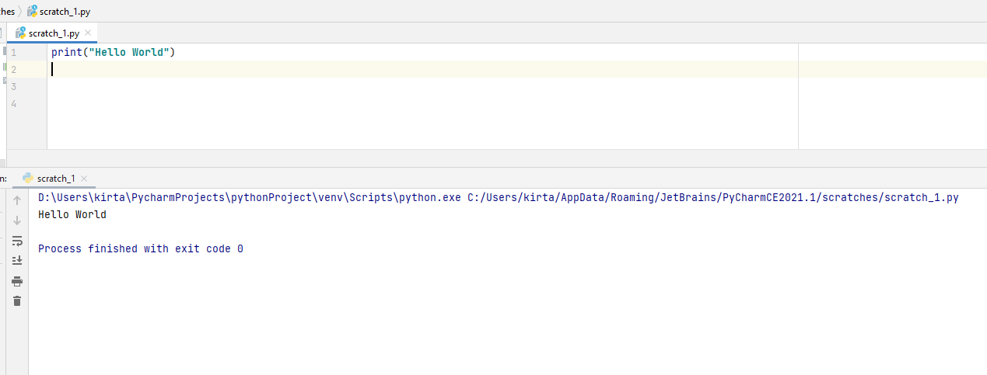

Declare and use a variable

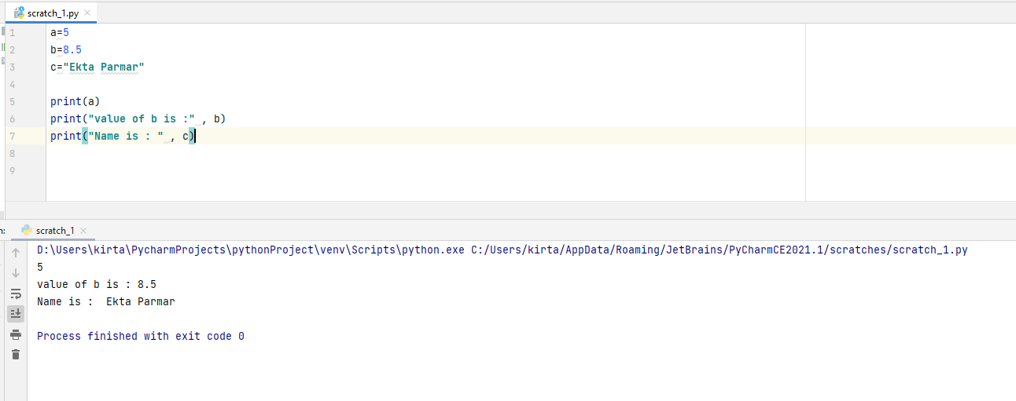

Changing the value of variable

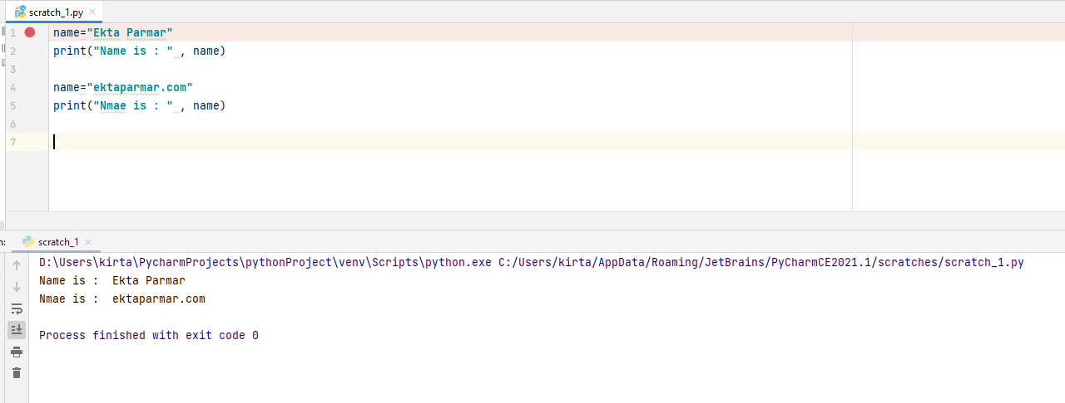

Assigning multiple values to multiple variables

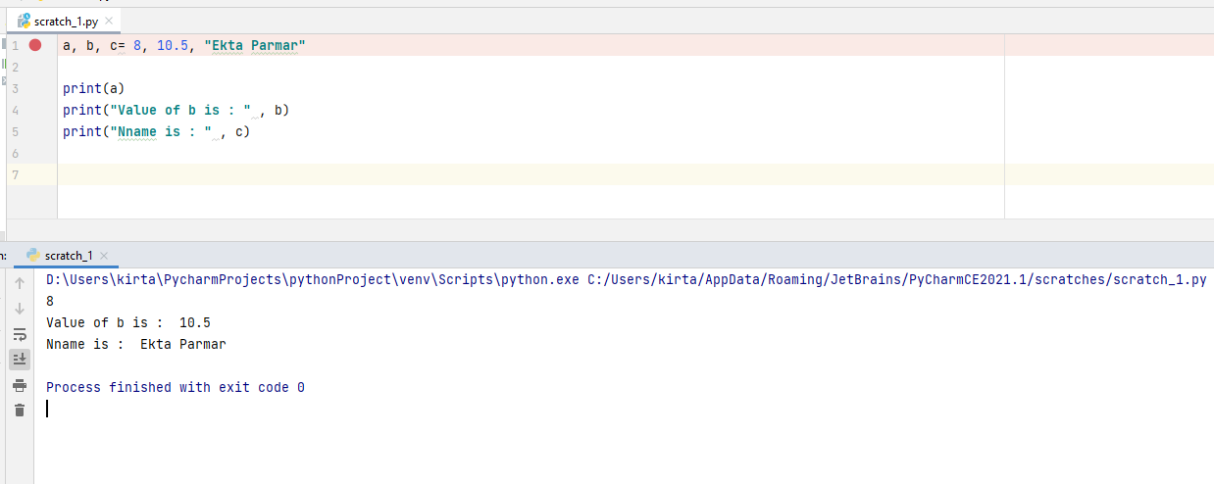

Assign same value to multiple variables

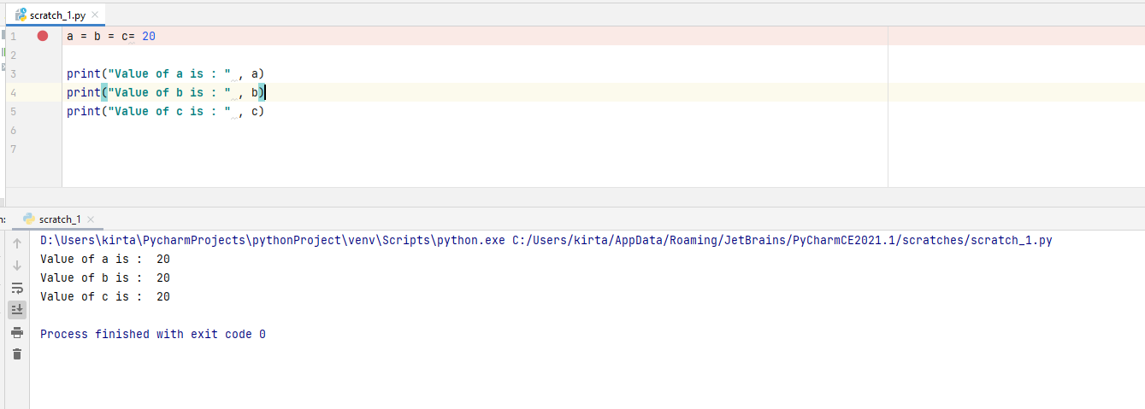

Number Datatype

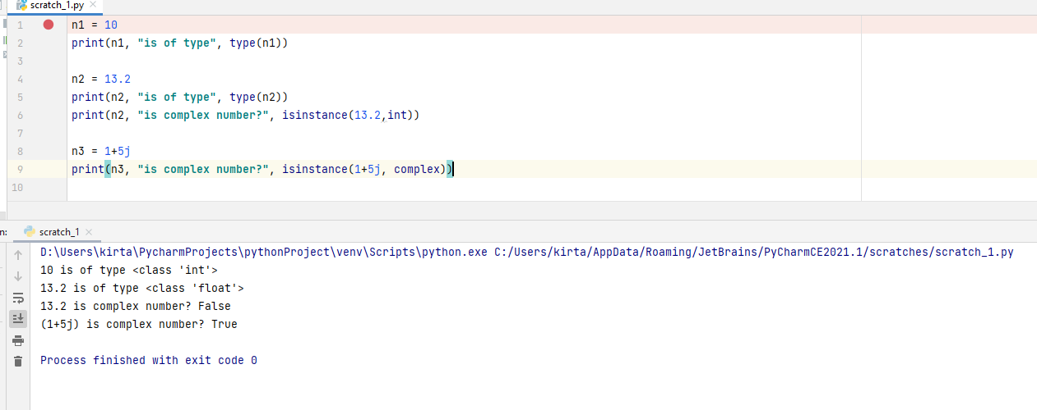

String Datatype

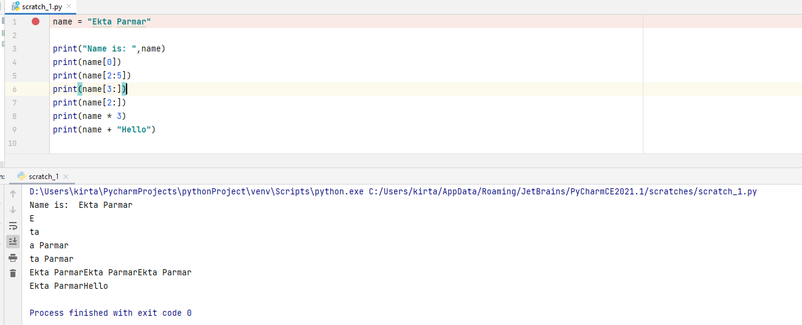

List Datatype

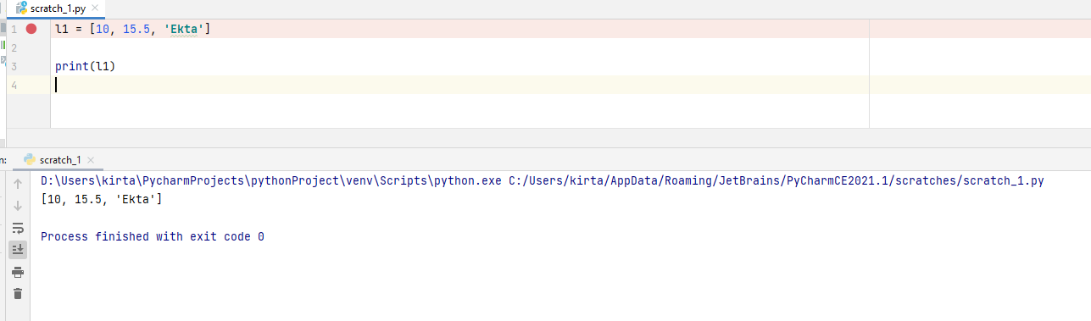

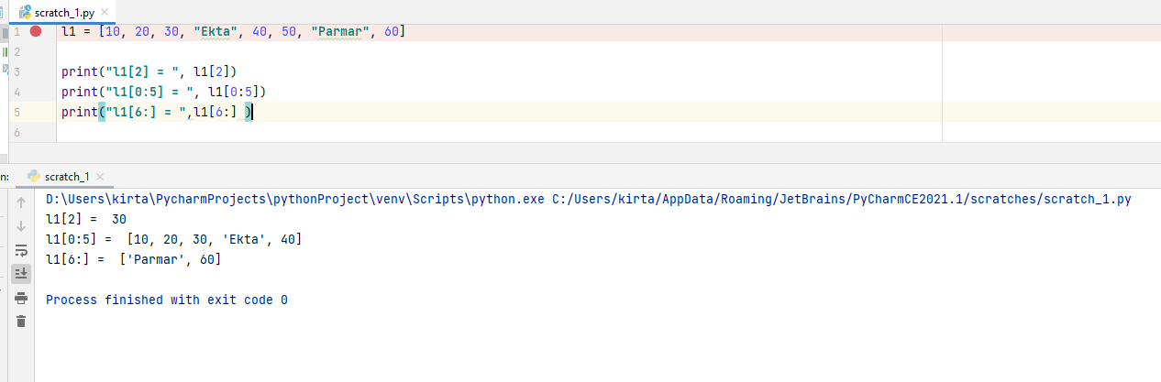

Tuple Datatype

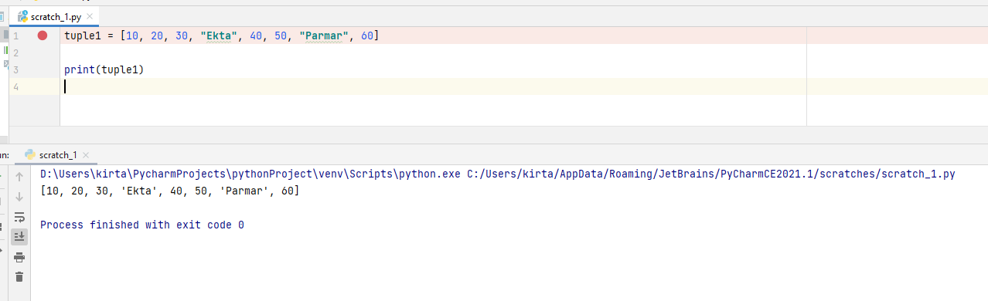

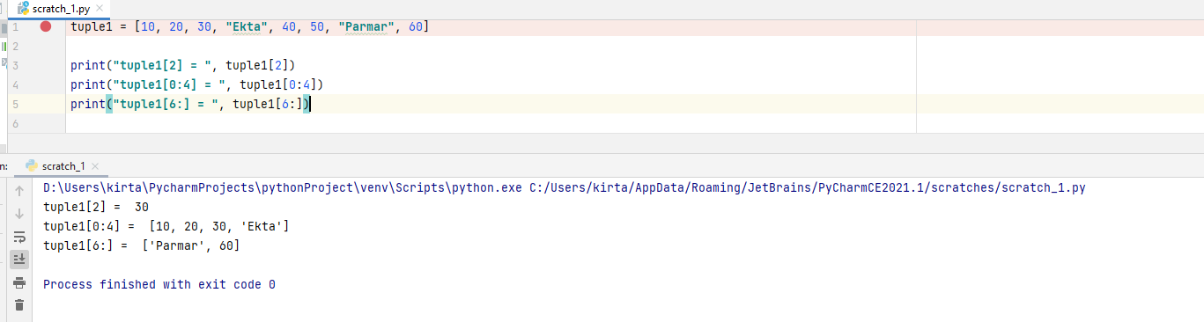

Dictionary Datatype

